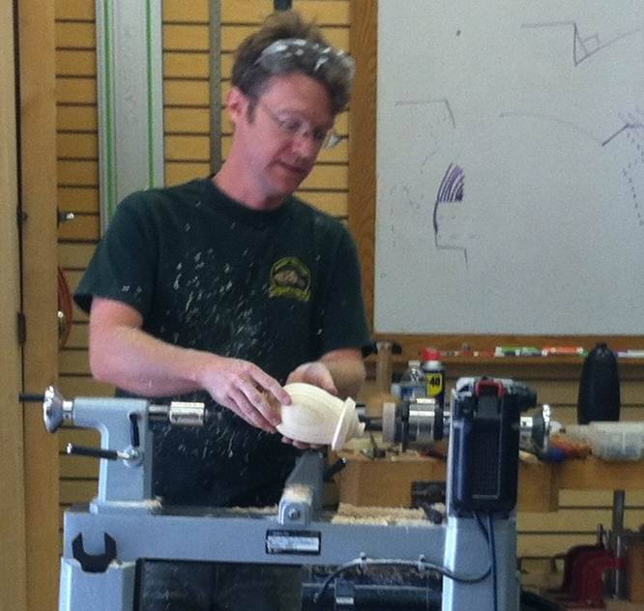
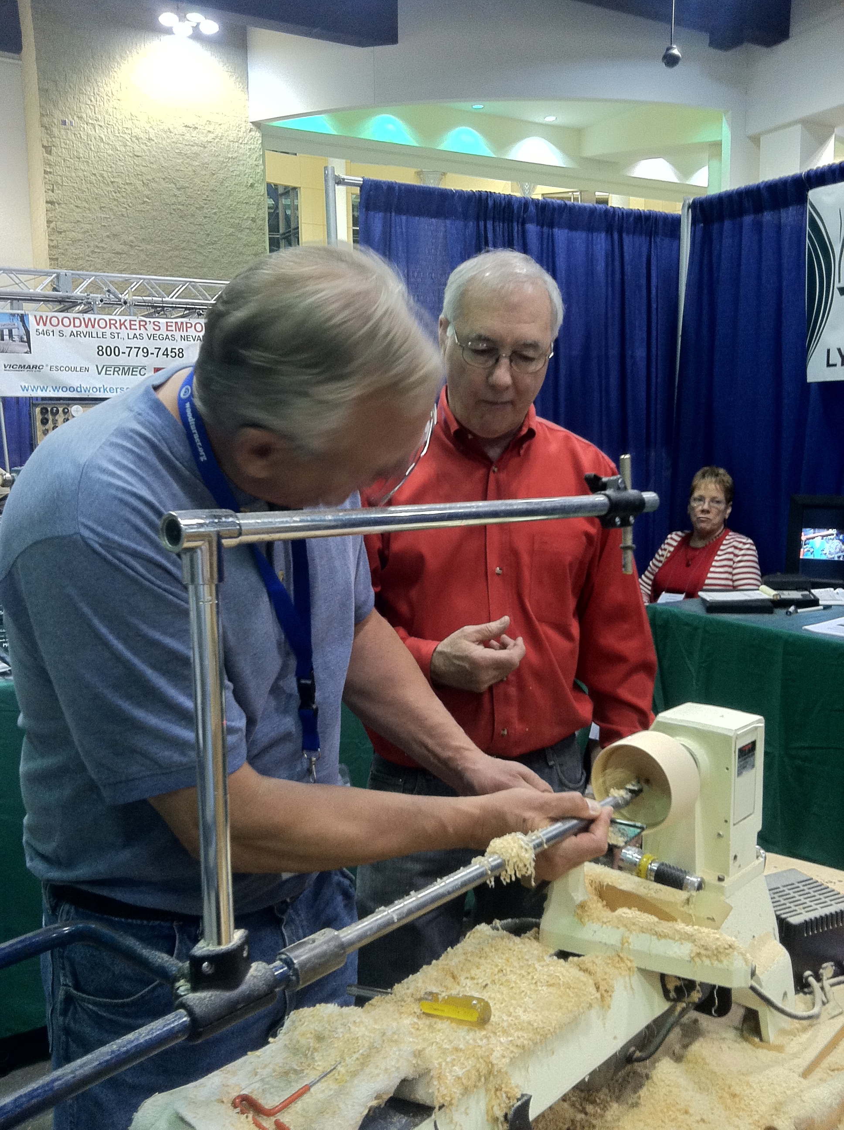
Opportunities to Increase Your
Woodturning Skills: Are You
Interested?

This is an MMAW survey regarding members’ interest in educational opportunities
outside of our monthly chapter meetings.

The MMAW Board of Directors has approved the purchase of our 4th lathe. In addition, the Paramount has funds to purchase a 5th lathe. This would allow a class size of 5 members to take in-depth hands-on classroom training. These classes could be taught by MMAW members, regional professionals or nationally recognized professionals who are members of the AAW. Tuition for these classes would be based on the instructor’s fee.

THIS IS NOT A FUNDRAISING EVENT, rather a benefit of membership.
We feel we have the talent within our membership to teach classes on various projects and techniques for first time wood turners, novice and intermediate skill levels.

A comparative example is offered by Woodcraft® in Bloomington. Some of their current offerings include:

Woodturning 101
Class Days:
Monday, October 08, 6:00 PM - 9:00 PM
Skill Level: Beginner
Class Size: 6
Tuition: $75.00

Turning a Custom Game Call
Class Days:
Thursday, October 25, 6:00 PM - 9:00 PM
Skill Level: Beginner
Class Size: 6
Tuition: $75.00
Tuition Notes: Blanks Not Included

Introduction to Bowl Turning
Class Days:
Friday, October 19, 9:30 AM - 5:00 PM
Skill Level: Beginner/Intermediate
Class Size: 6
Tools Required:1/2" Bowl Gouge, Safety Glasses, Notebook
Prerequisite: Some Lathe Experience
Tuition: $140.00
Tuition Notes: $30 Materials Fee

Keep in mind; this doesn’t include the 3 hours in roundtrip travel and gas!

The MMAW Board feels a reasonable stipend for a MMAW member to teach a class here in St. Cloud would be $25 per classroom hour. Keep in mind that the instructor typically invests more than twice the classroom time in preparing, set-up and incidental expenses. The length of the class would be determined by the instructor and the topic. The tuition would be determined accordingly. Classes would be held at the Paramount Visual Arts Center unless otherwise noted. Please complete the survey on the next page and return it the MMAW by Friday October 19th, 2012.

- I would be interested in attending a project or “technique specific” hands-on classes taught by a MMAW member at approximately $25 to $50 per class.

My preferred day for the class would be:
- Monday – Friday, during the hours of 10AM-5PM
- Monday – Friday, during the hours of 5PM-9PM
- Saturday, during the hours of 10AM-4PM

Classes I would be interested in taking could be:
- Basic bowl turning
- Advanced bowl turning
- Hollow form vessel
- Pen turning
- Finishing (could include; sanding, wipe-on and spray finish, waxing and buffing, etc.)
- Sharpening
- Tool making
- Surface embellishments
- Tops and toys
- Christmas ornaments
- Jewelry
- Peppermills and Salt Shakers
- Segmented turning
- Fishing Lures
- Game calls
- A table lamp

Your suggestions: _____________________________________________
_____________________________________________
_____________________________________________
- I would be interested in teaching a class. Note: Instructors must be a current AAW member.
Please contact me. My name is: _____________________________

A nationally recognized professional (i.e., Trent Bosh, Jimmy Clews) costs $625 to $700 per day plus travel expenses and per diem (approximately $1,000 per day to bring them to St. Cloud). At this price, a hands-on class could run as much as $200 per attendee. An all-day demonstration could run $25 per member, provided at least 40 members attend.
- I would be interest in the hands-on opportunity with a nationally recognized professional.
- I’d be interested in the all-day demonstration.

Comments:

Contact Gary Mrozek gary@treesremembered.com for more details. If you will not be attending the October 13th Chapter Meeting, we encourage you to print and mail to MMAW, PO Box 227, Sartell, MN 56377 or email your comments to gary@treesremembered.com

